THIS IS A PRACTICE ASSESSMENT. Show formulas, substitutions, answers (in spaces provided) and units!

An electron is in a straight wire conductor that is being pulled perpendicular to a magnetic field having a strength of B = 0.750 T at a speed of 45.0 ms⁻¹. The wire is oriented in a north-south direction and is being pulled to the west. The B-field is oriented downward.
1. What is the magnitude of the magnetic force that the electron experiences during the motion of the wire through the magnetic field? 1. _________________

2. What is the direction of the force? Explain how you find this out. 2. _________________
__________________________________________________________________________________
__________________________________________________________________________________

The following questions are about Faraday’s law and Lenz’s law.
3. State Faraday’s law.
__________________________________________________________________________________

4. State Lenz’s law.
__________________________________________________________________________________

5. Formulate a convincing argument for Lenz’s law. In other words, why must the induced flux change act in such a way as to minimize the original flux change? ___________________________________
__________________________________________________________________________________

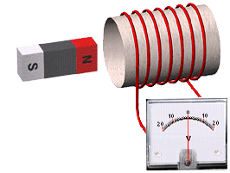
A wire is wrapped around a toilet paper tube (diameter 6.0 cm) and connected to a voltmeter, as shown. A bar magnet (B = 0.35 T) is oscillating in and out of the tube 60. times each minute, as shown by the double arrow. When thrust in a right-ward direction, the voltmeter needle deflects to the right to a maximum of 10. V.

6. If you increased the oscillation rate to 125 times each minute, what would the maximum voltage read? 6. ______________

7. How many more loops would you need to add if you wanted the maximum voltage to read 20. V? Assume the oscillation rate is back to its original value. 7. _________________

8. If the diameter of the tube is doubled, but the oscillation rate and the number of loops are back to their original values, what would the maximum voltage read? 8. _________________

A coil of wire resting on a tabletop and having 125 turns and an area of 5.00 cm² is immersed in a magnetic field (0.750 T) which is pointing upward.
9. What is the flux through a single loop? 9. _________________

10. What is the flux linkage through the coil? 10. ________________

11. What is the induced emf if the magnetic field remains constant? 11. ________________

12. If the magnetic field decreases to 0.25 T in 0.50 s, what is the rate of change of the flux linkage through the coil? 12. ________________

13. What, then, is the induced emf? 13. ________________

14. What is the direction of the induced current in the coil, as viewed from above the table? Which law tells you this? 14. ________________
________________

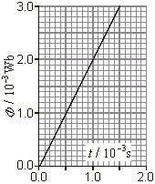
A coil having 375 turns is subjected to a time-dependent magnetic flux as shown in the graph.
15. What is the flux at t = 0.0015 s? 15. ________________

16. What is the flux linkage at t = 0.0015 s? 16. ________________

17. What is the magnitude of the emf induced in the coil?
17. ________________

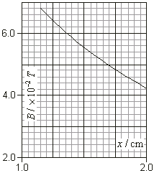
A coil having an area of 1.50×10 ⁻³ m² and 250. turns is moved in the magnetic field of a magnet between P and Q as shown. The distance the coil is from the face of the magnet is x. The variation in strength of the magnetic field with x is shown in the graph.
18. What is the flux linkage when the coil is located at x = 1.25 cm? 18. ________________

19. What is the flux linkage when the coil is located at x = 1.75 cm? 19. ________________

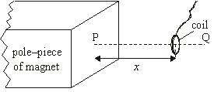
20. If the coil was moved from the first position to the second one in 75.0 ms, what is the induced emf in the coil?
20. ________________

